zs-ms-zelec.joo-sol.cz

3) We need to increase the space under H1..H3. Pct in attachment.
Reply: Done
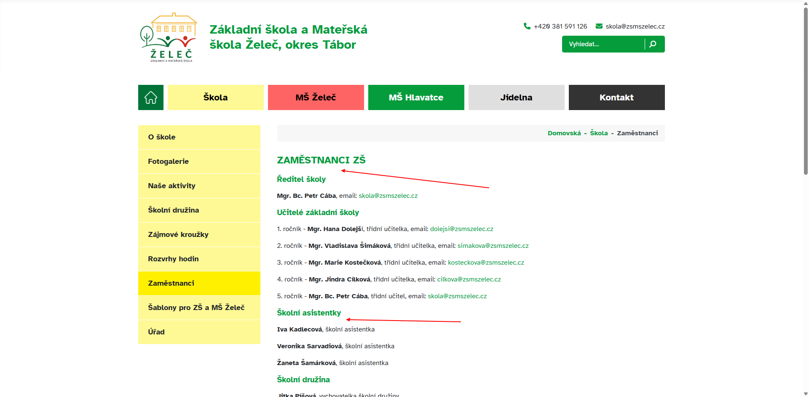

4) Change "Domovská" => "Domů"
Reply: Done

9)
a)
Can you change the transition effect between photos so that they don't flicker, but blend together?
Reply: Done.
b)
When I scroll through the photos using the keyboard, their order is not followed. https://zs-ms-zelec.joo-sol.cz/skola/nase-aktivity/zs-zelec-skola-v-prirode.html?layout=fotogalerie – when I scroll through the photos using the arrow keys on the keyboard, the photos are displayed as follows: 1 – 3 – 5. Photos 2 and 4 are skipped.
Reply: Done.

11) Yes, I want it to work like this on all websites. I hope you're not going to do this manually? But be careful. It is related to problem no. 9
Reply: Done.

12) Yes, I want it to work like this on all websites. That's why there is a label on the upload form 🙂 I hope you're not going to do this manually?
Reply: Done.

15) Change the behavior in the hamburger menu as shown in the attachment.
Reply: Done
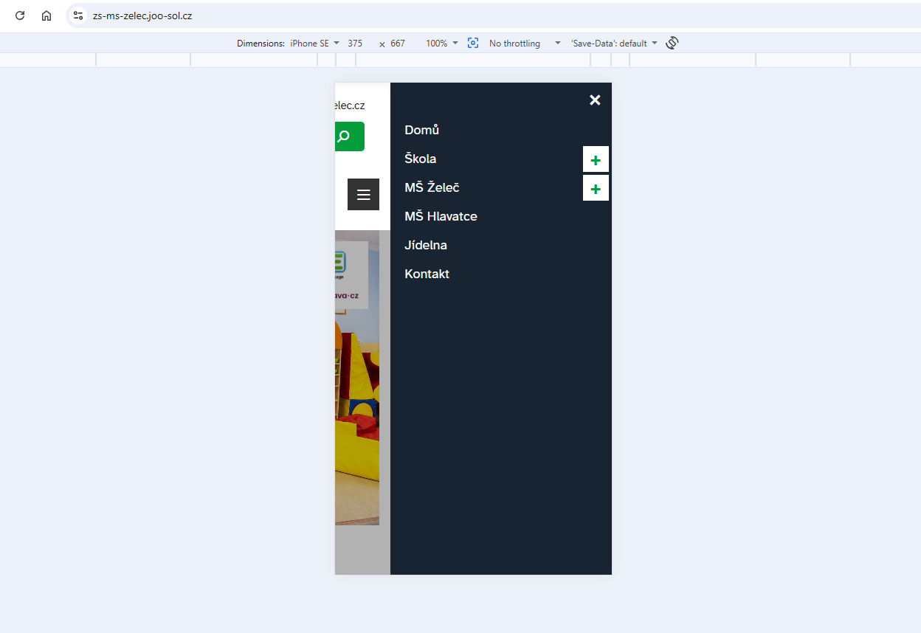

16-17) From customer:
Points 16 and 17, thank you for the adjustments, I would just like to please turn it around. A saturated color on the Home page in the top menu and a lighter one when selecting (this also applies to red). Is it possible to somehow coordinate the shades of the colors together? I would like them to match the logo as much as possible (red is darker, not so flashy, yellow is similar, etc.
Reply: Done.
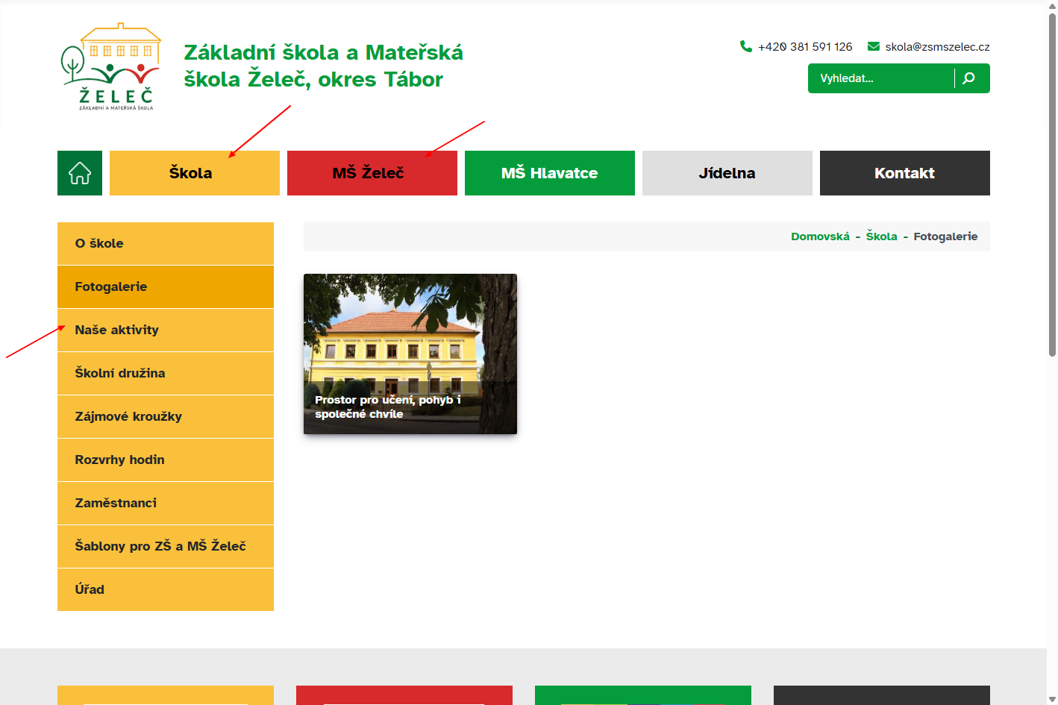

19) From customer:
Done, but – when I write the address to the Hlavatce Kindergarten in the mobile version, the text crawls into the upper map. Moreover, the edits in the web version are not entirely convenient. Can it be solved differently? For example, similar to the one in the footer? Or just a link through the address? Will the map open?
In attachment.
Reply: Done, Also fixed that in the web version.
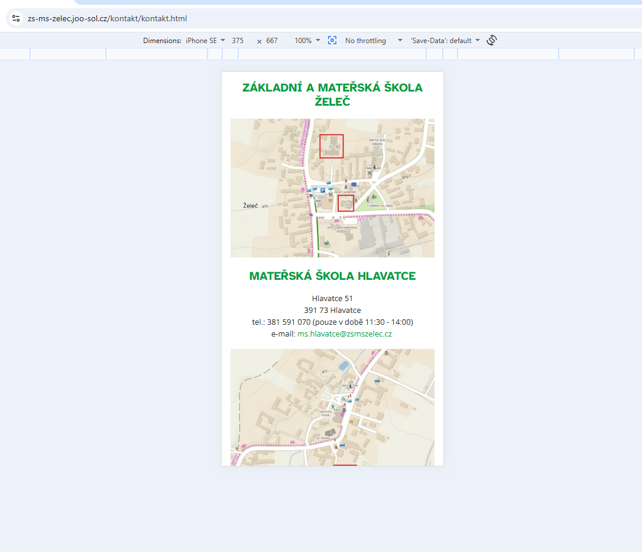

24) From customer:
just please change the logo (without http://Strava.cz) Please change the EduPage test logo to a new one (without http://Strava.cz) will you download it yourself? I don't know what format you need. I found it here, for example. https://play.google.com/store/apps/details?id=air.org.edupage&hl=cs
Leave only 1 logo....
Reply: Done.
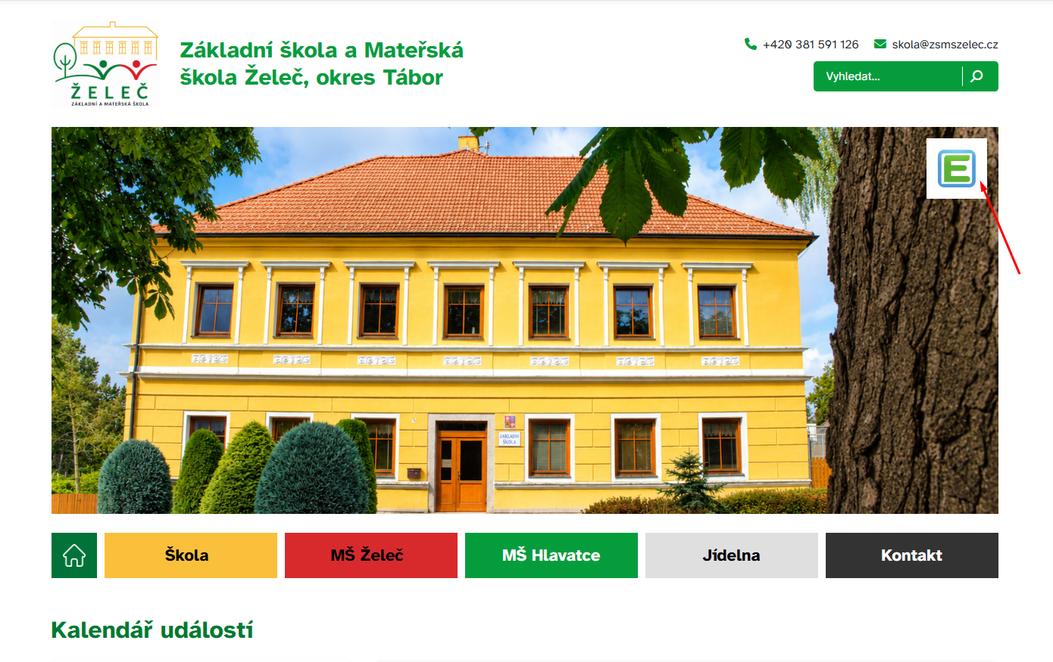

28) We probably have a problem with the superfluous word "Předmíř" on all websites. In the article:
https://obec-vesce.joo-sol.cz/prohlaseni-o-pristupnosti.html
Can you use a script to find and remove it everywhere?
Reply: Done.

32) Please replace the school's test logo with a new one - I uploaded it to Media - the file is named: Logo_FIN_FIN.png
Reply: Done.

